Access Scratch Through this link : <https://scratch.mit.edu/>

Activity 1: Students will be responsible to identify the rule for the input/output table in problem 1 of the 5.1 worksheet. After the student believes they have identified the rule they will create this scratch project to use Computer Science to check their work with the input and output table of the worksheet.

1. Make an account by going on the Join Scratch tab present in the header of the website click on highlighted “Join Scratch”.



1. Follow prompts after pressing join scratch to create an account.

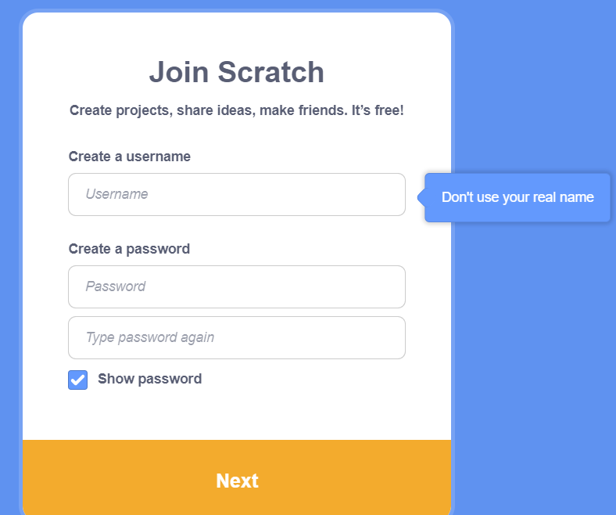

1. Once the account is set up press create highlighted in the top left corner of your screen.



Jumping Game Instructions

Link to final project : <https://scratch.mit.edu/projects/758495705>

Link to YouTube Explanation Video : <https://www.youtube.com/watch?v=1jHvXakt1qw>

1. Press on the icon that appears as a cat in the bottom panel of the screen reference snippet below.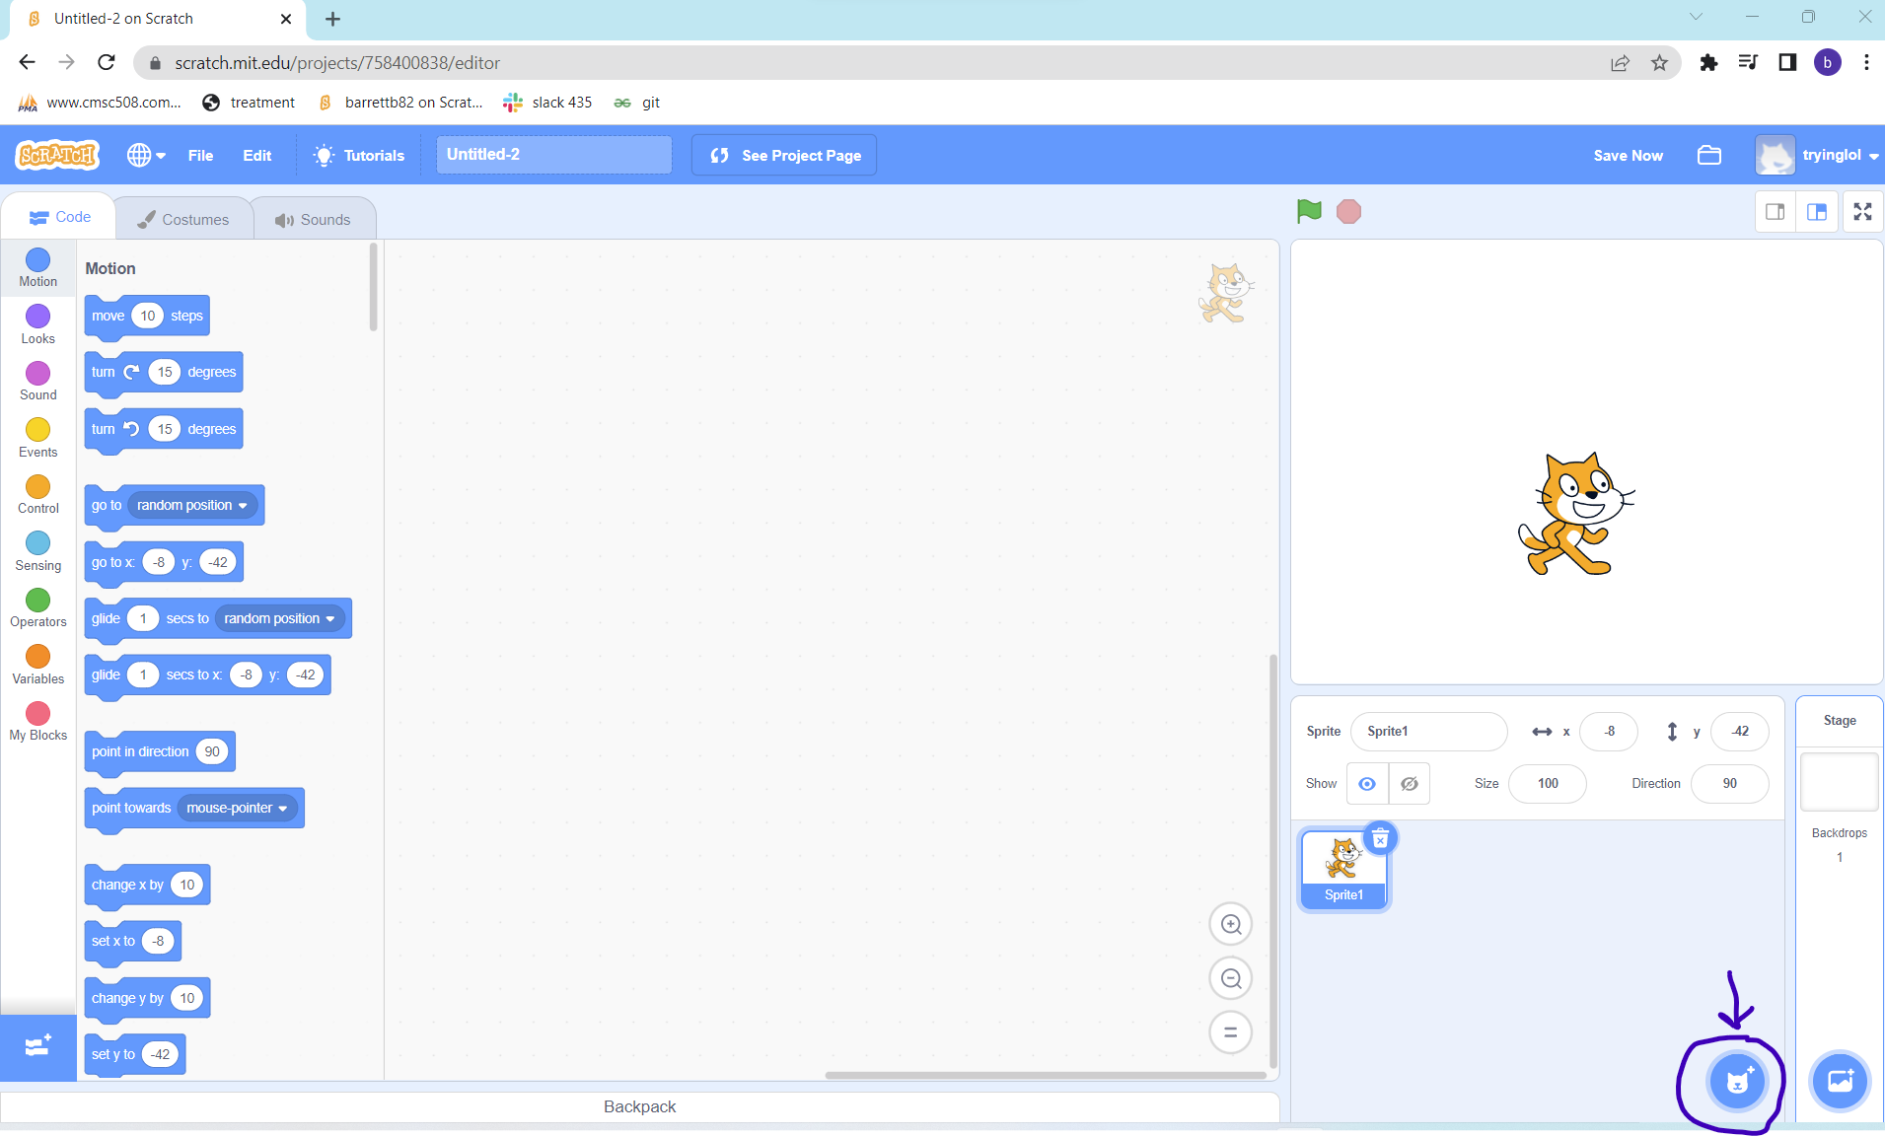
2. Once in a sprite window pick the sprite image that is a chick you may have to scroll down until you see it or in the search bar write chick. 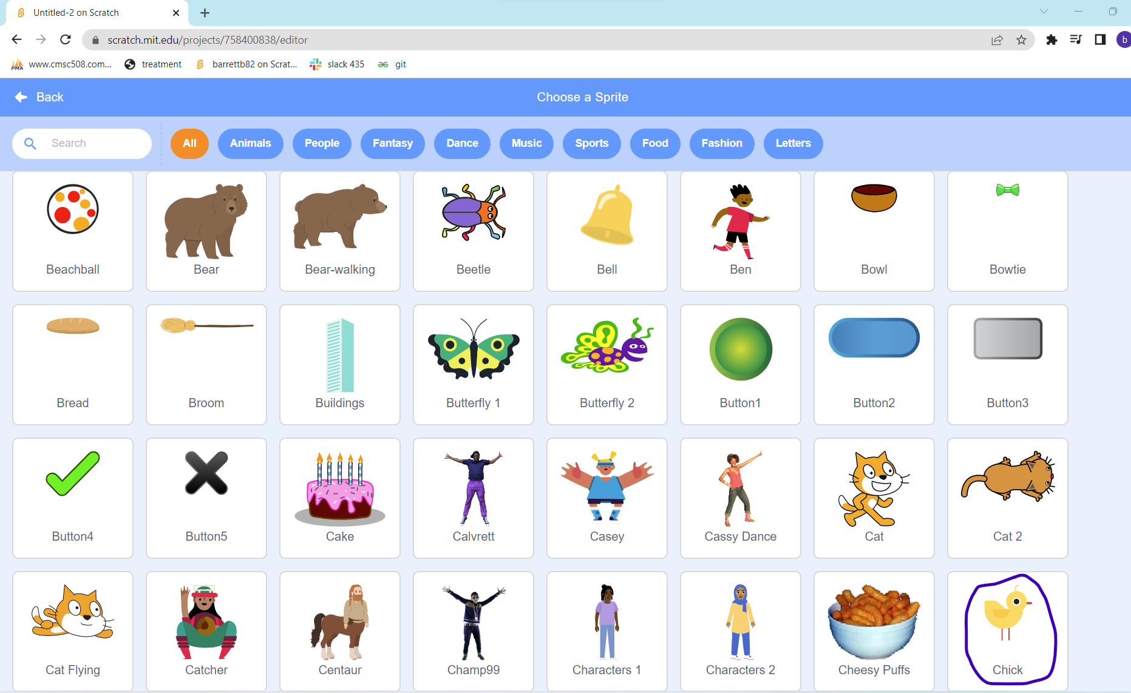

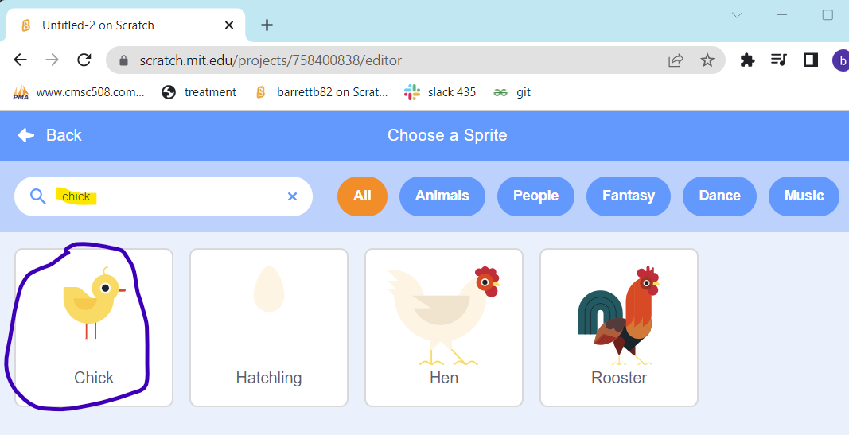

1. Then hover mouse over the default sprite1 and click the trash bucket on top right to discard. Once the trash icon is clicked only one sprite should remain. When the chick sprite is clicked change the chicks setting to the highlighted below. 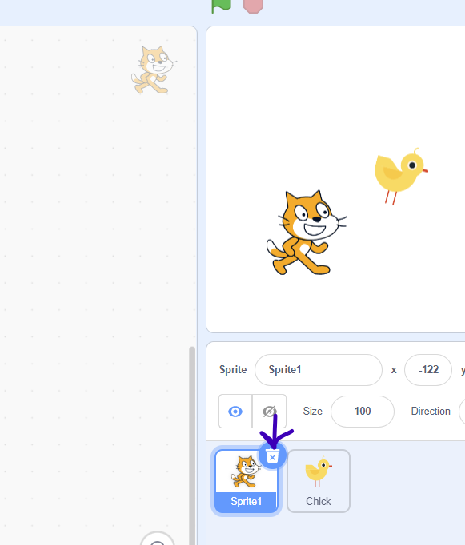

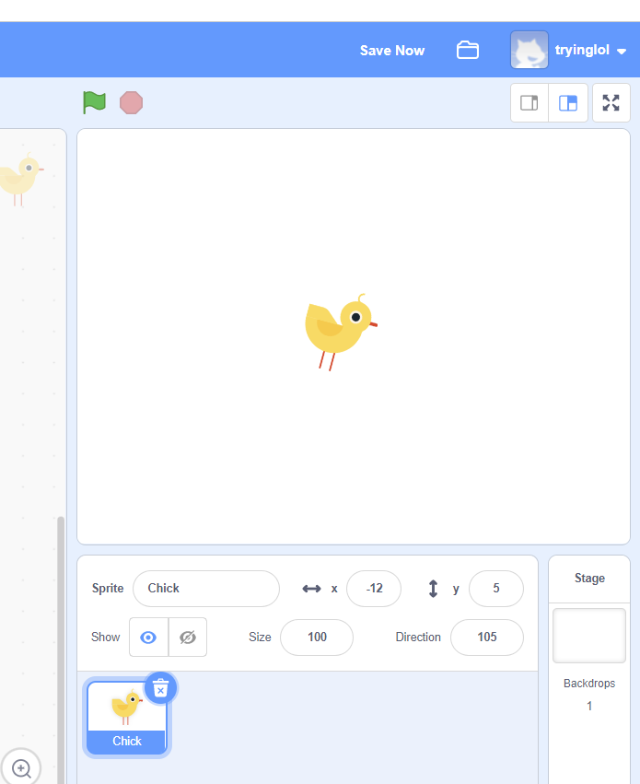

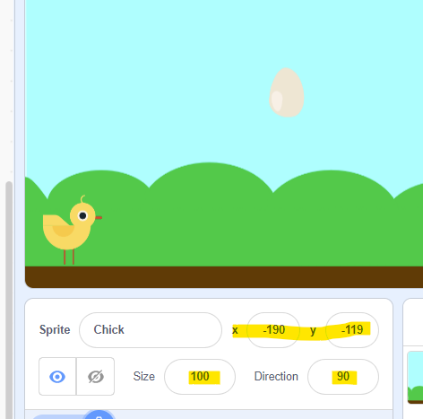

1. Click on the landscape icon in the bottom right corner present in the snippet below. Select Blue Sky landscape within the backdrop category. Once clicked on the backdrop the Blue Sky should be set in the sprite window.

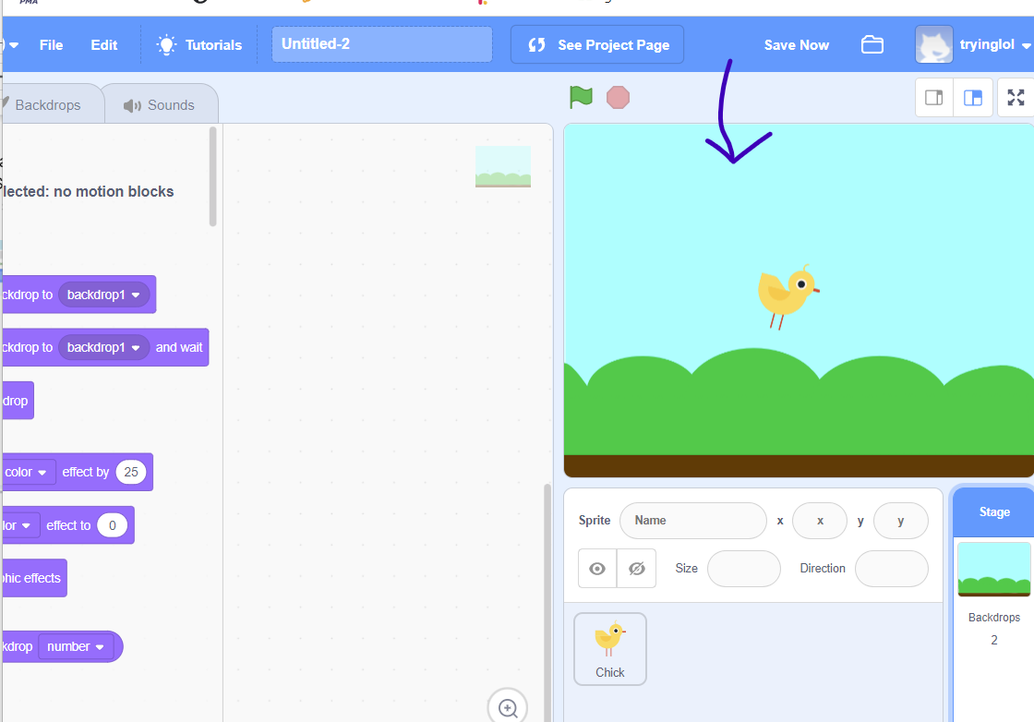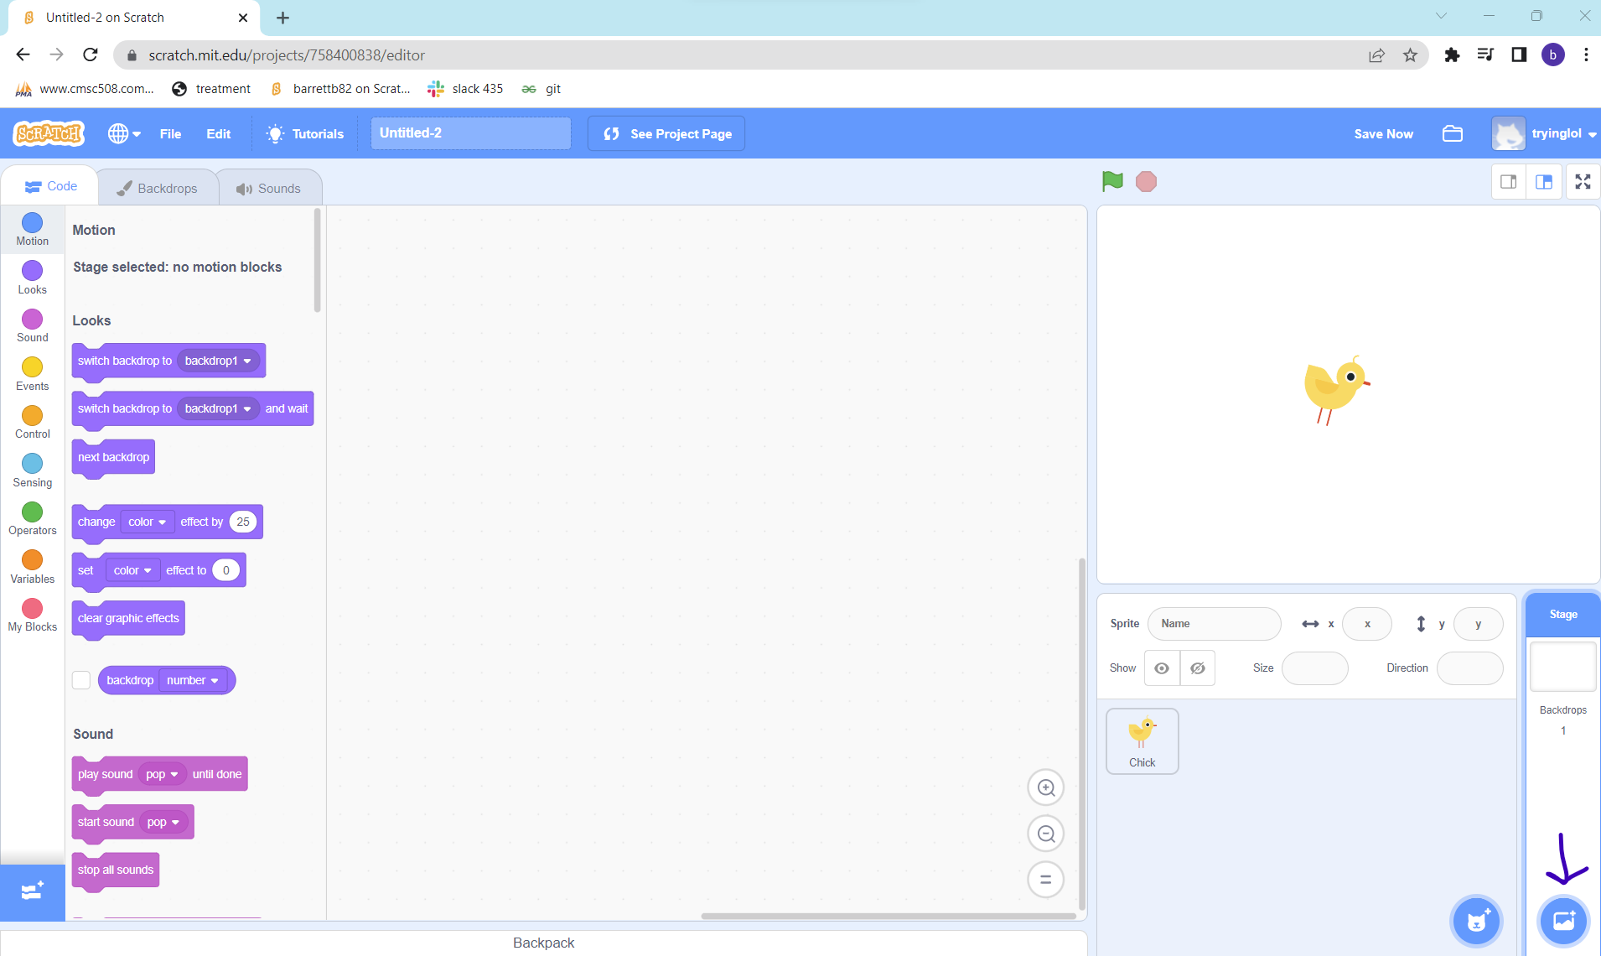

1. Make sure for this step and steps to follow that you click on chick sprite before clicking on the motion category. If the sprite is clicked then there will be a blue highlight around the sprite indicated with the first arrow. Then press on the motion category indicated by the 2nd. Lastly drag the “change y by 10” block indicated with the 3rd arrow and drag into the center panel as shown in the snippet below.

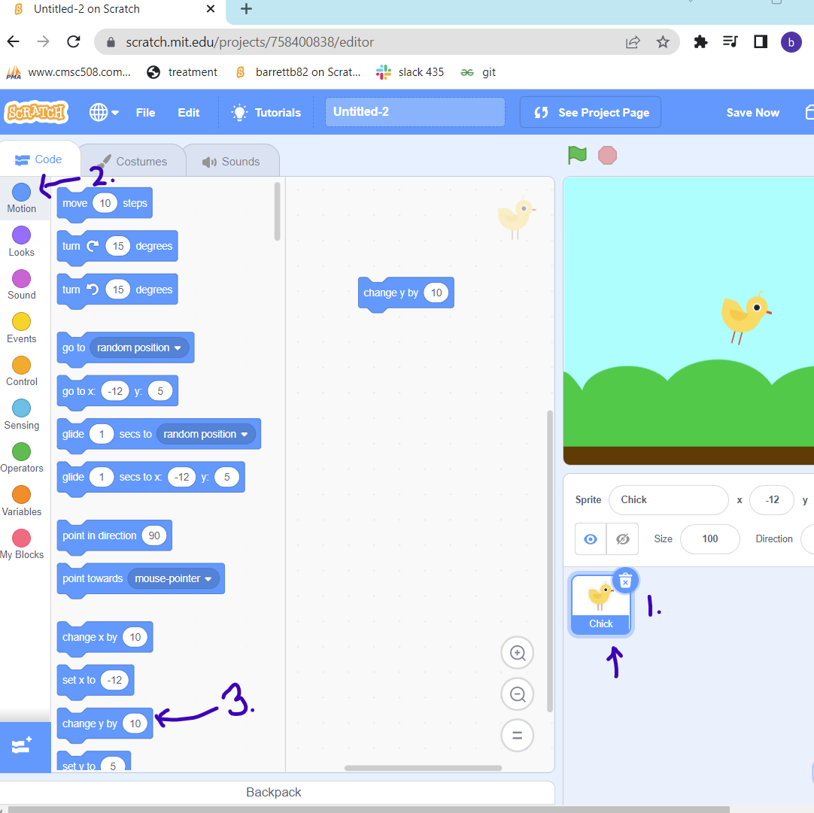

1. Click the control category indicated with the first arrow in the snippet below and drag the repeat 10 block placing it to wrap the change y by 10 indicated by the second arrow in the snippet below.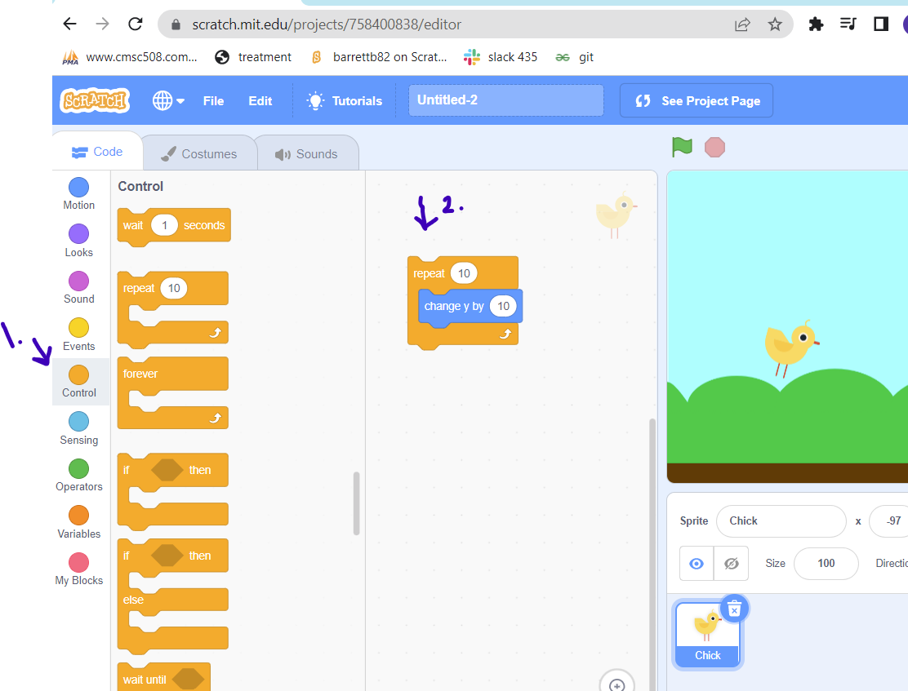
2. Within control select another repeat 10 block and pull it to attach to the last repeat 10 block.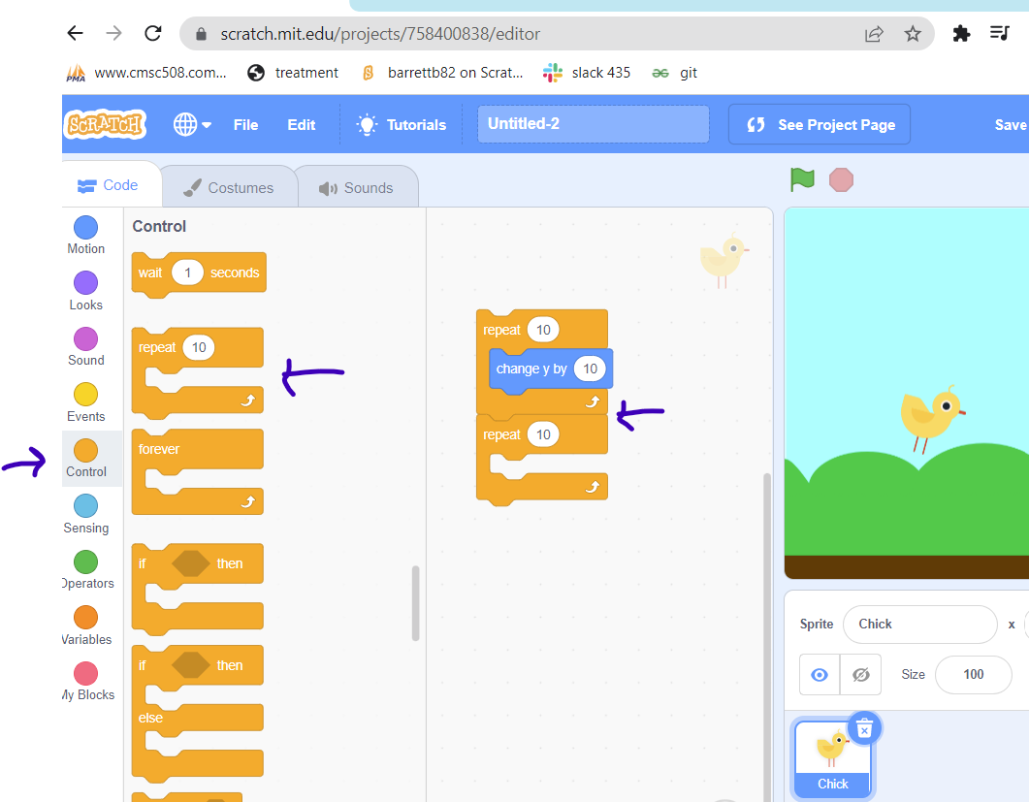
3. Then go into the motion category and drag the change by 10 into the center of the second repeat block. Once it is in the middle of the second repeat block change the 10 to -10.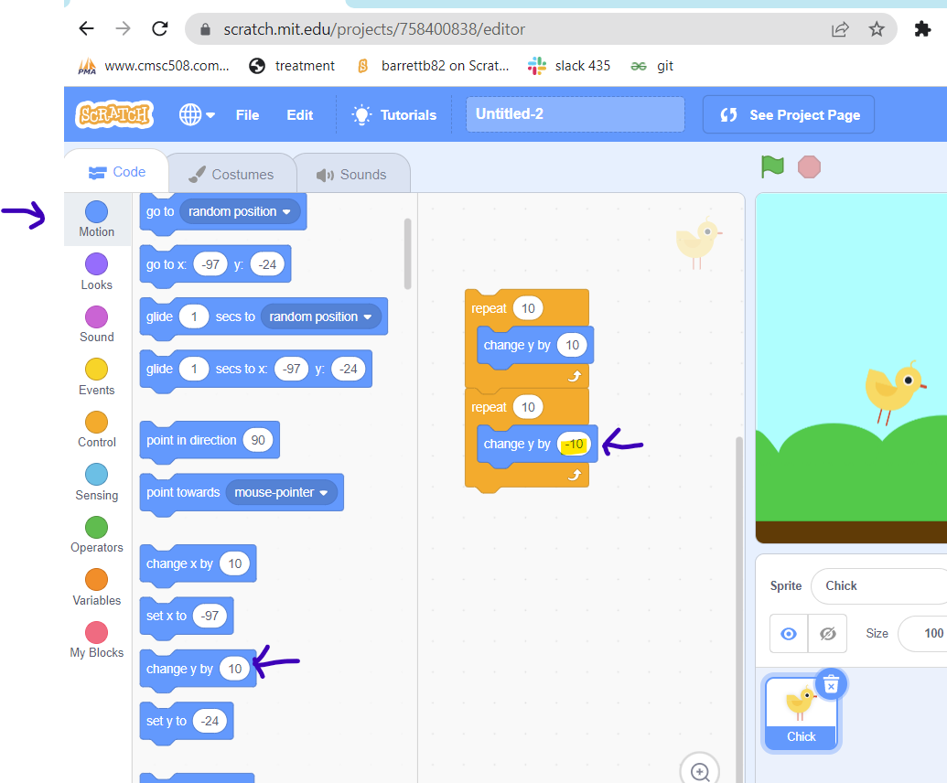
4. Then go into events and drag the space key pressed and place it on top of the first repeat block.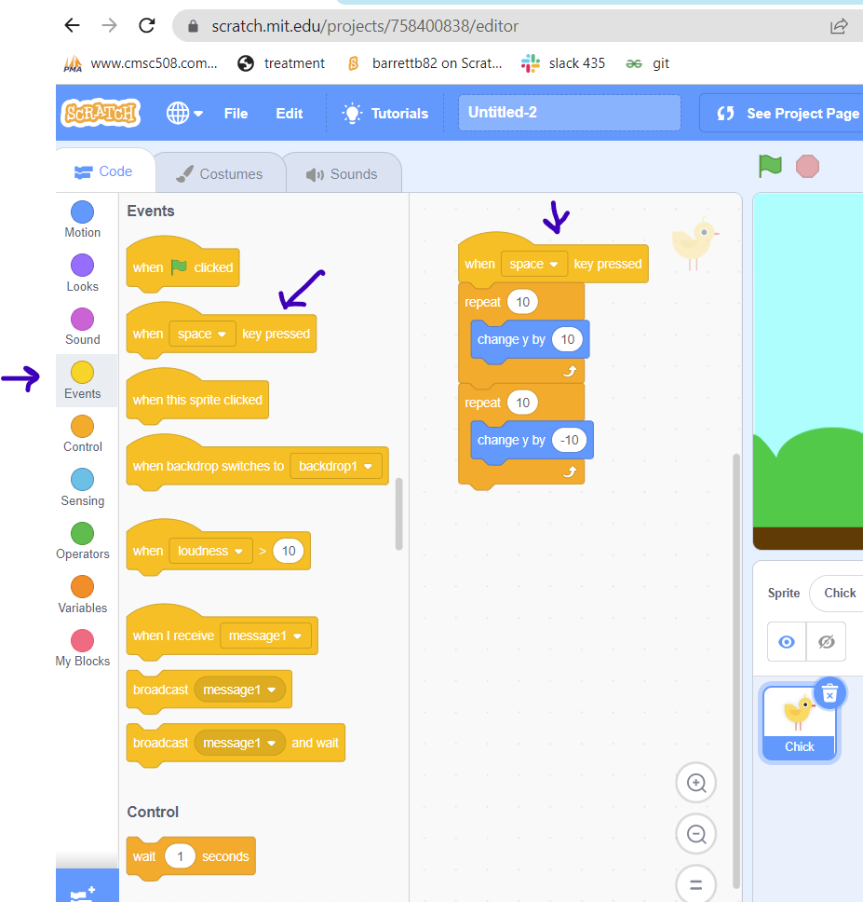
5. Then go into the sound category and select the start sound chirp. Drag the start sound chirp to be in between the first repeat block and also after the space key pressed.

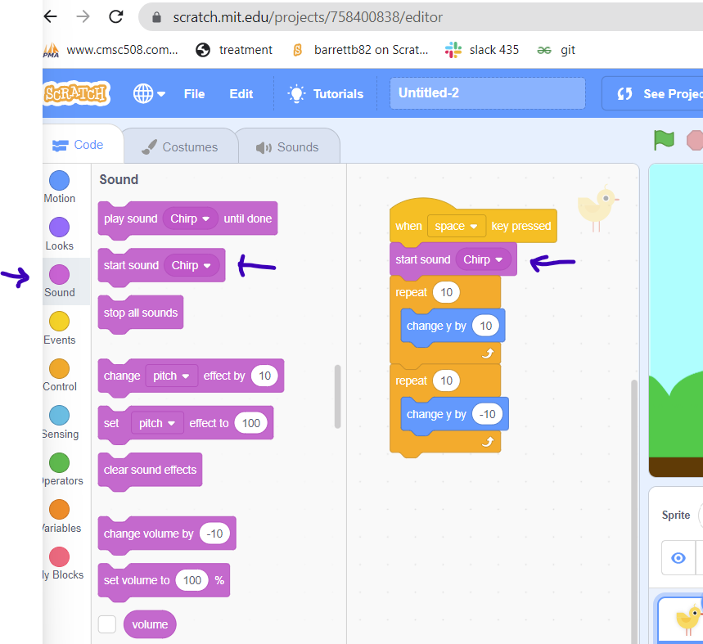

1. Then choose a sprite that will be an obstacle for the chick to jump. The way to do this is click on the cat icon in the bottom right panel. In this model program we will pick the egg sprite which can be found by searching for the egg in the search bar. Once clicked on the egg make sure the settings are set to below snippet.

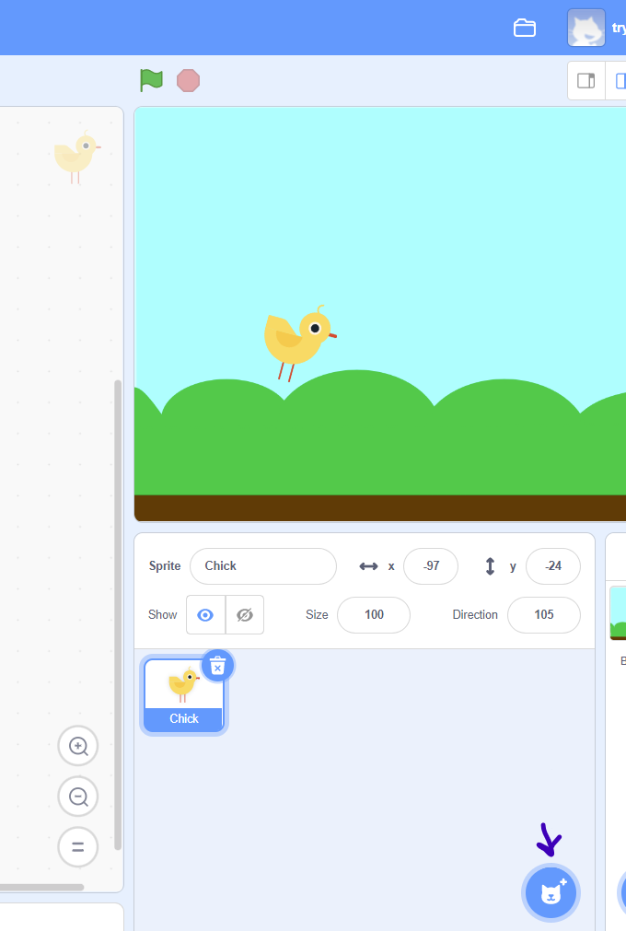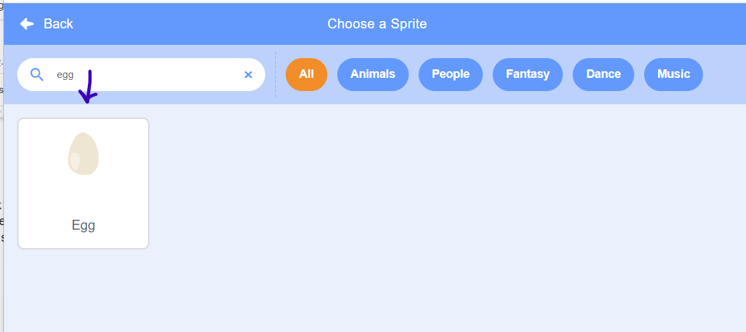

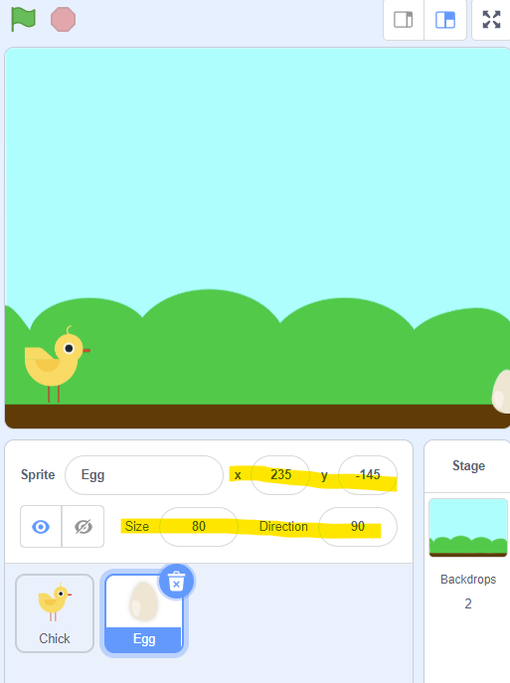

1. Make sure for this step and steps to follow that you click on egg sprite before clicking on the motion category. Go to the motion section. Drag the go to x: value y: value. Then attach the go to x block to the block glide 1 secs to x: value y:value.

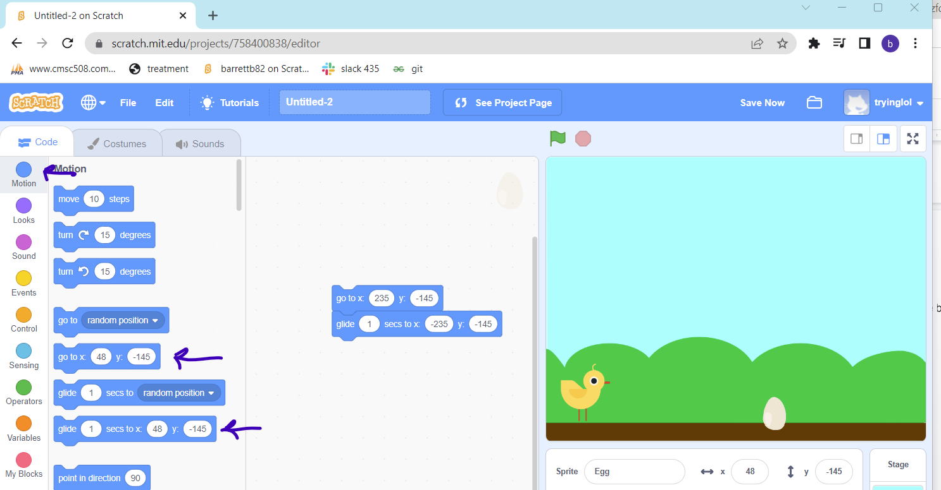

1. Go to the control category and drag the forever block to wrap the glide block and go to x blocks that are in the center panel.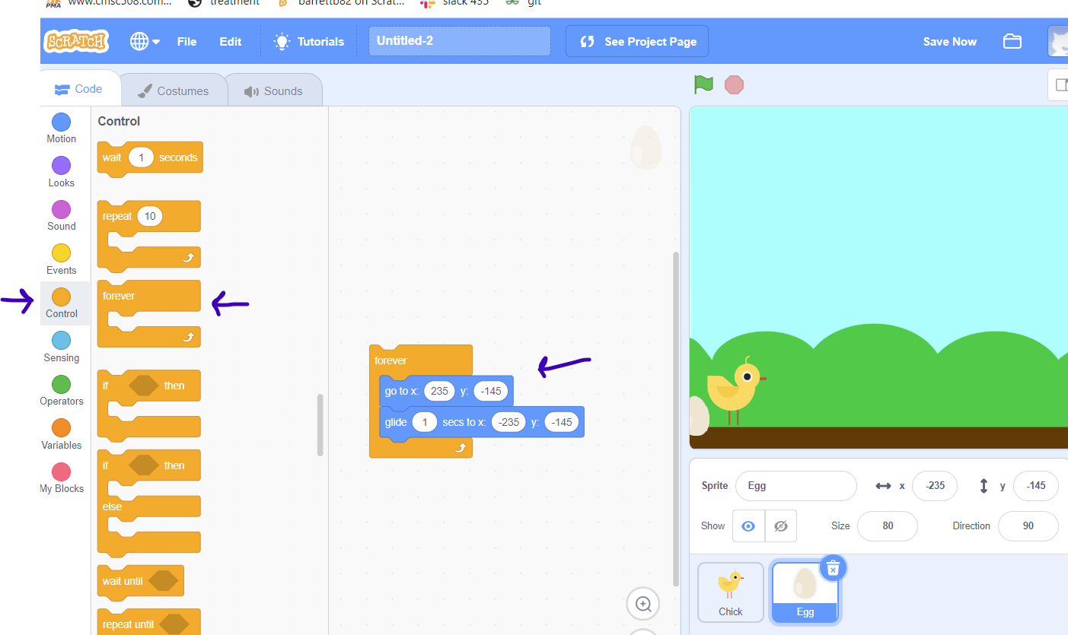
2. a
3. Go into the events category and drag the when flag clicked to go on the top of the forever block.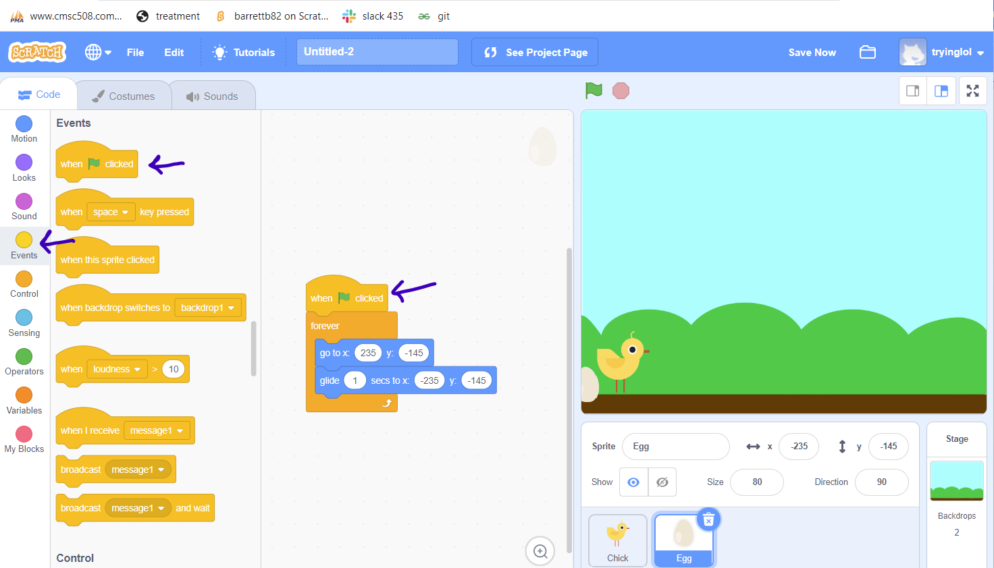
4. Go into the control category and drag the stop all. Into the panel at the top.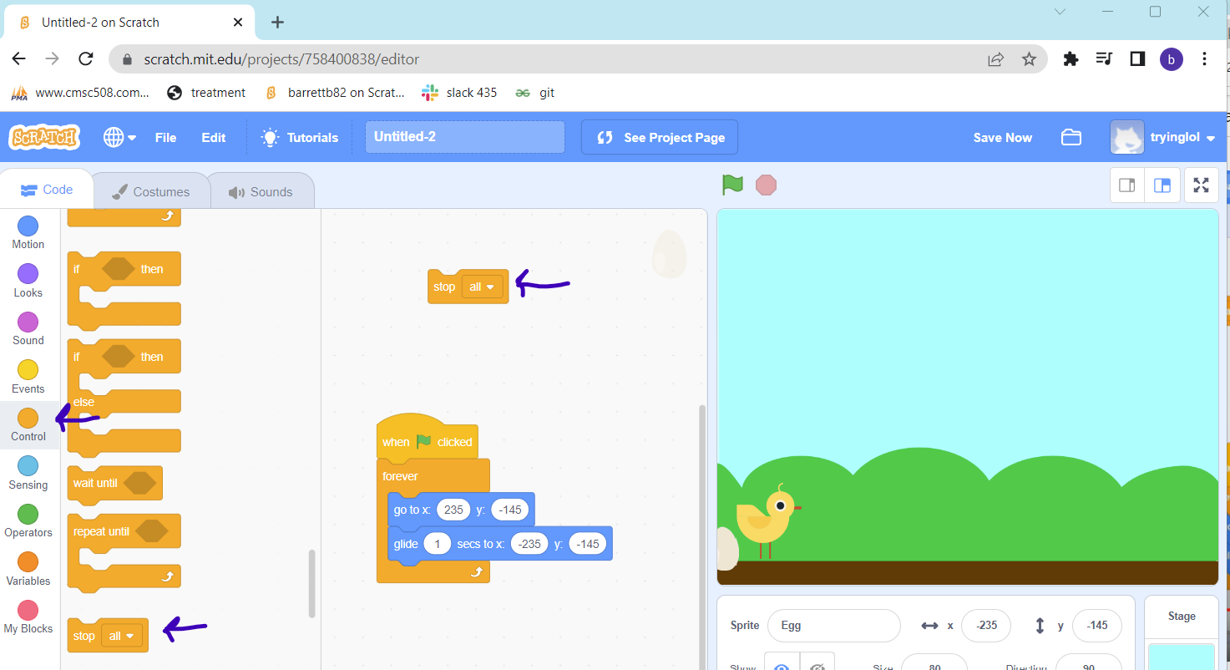
5. a

17. Drag the wait until block also in the control category into the middle panel and attach on top of the stop block. Then go into sensing and drag the touching mouse pointer block into the hexagon in order to get it into the hexagon. When dropping hold the block over the right side of the hexagon. When the touching block is in the hexagon click your mouse on the “mouse-pointer” drop down and select chick.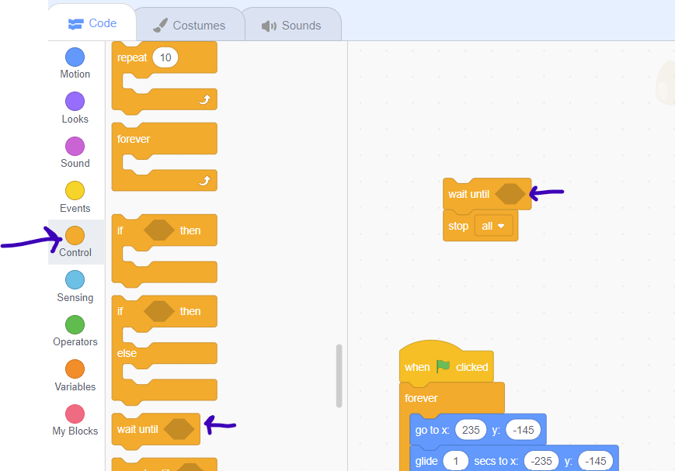

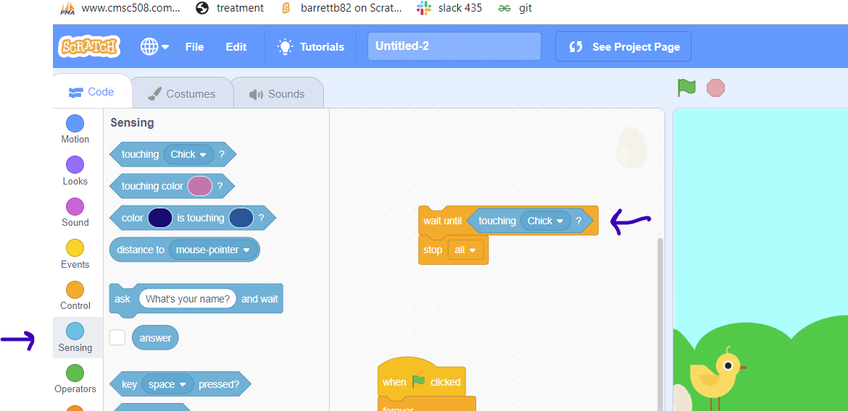

1. Then go to the events category and attach the when the green flag clicks to the top of the wait until block.

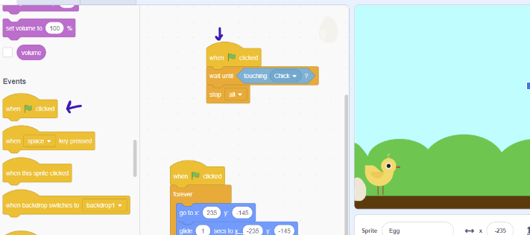

1. Press on the chick sprite and go into the motion category pull in the go to x: value y: value. Make sure the values in the x is -180 and the y is -120.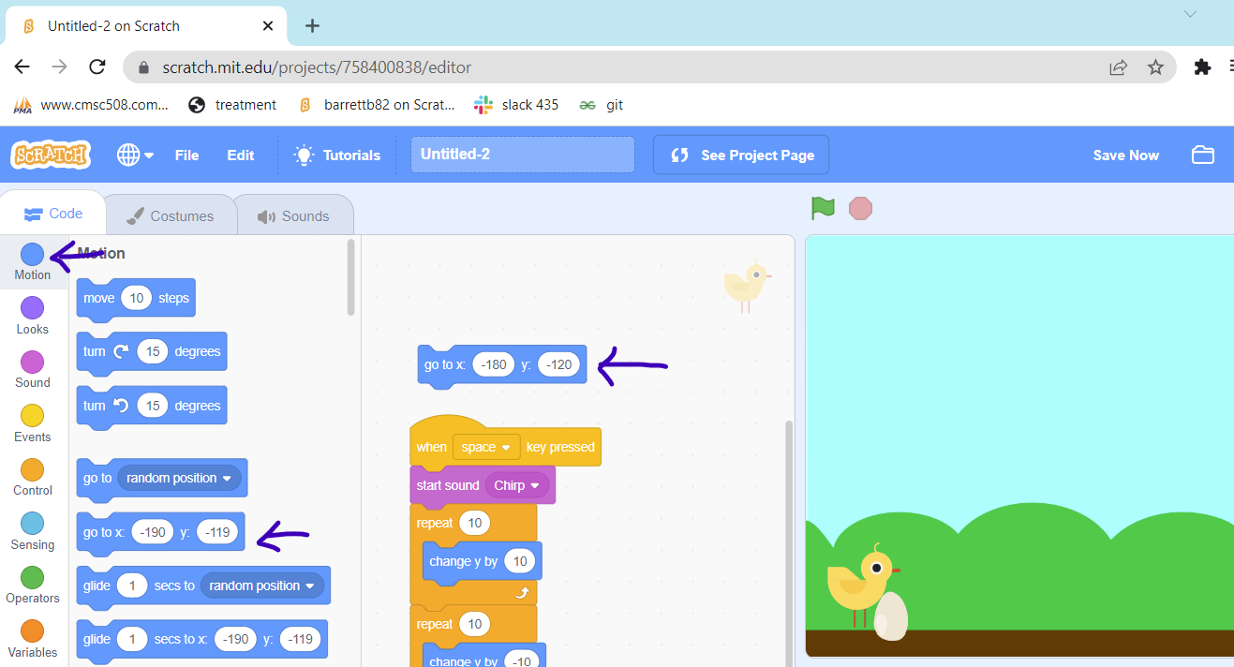

20. Then go to the events category and attach the when the green flag clicks to the top of the go to the x: block.

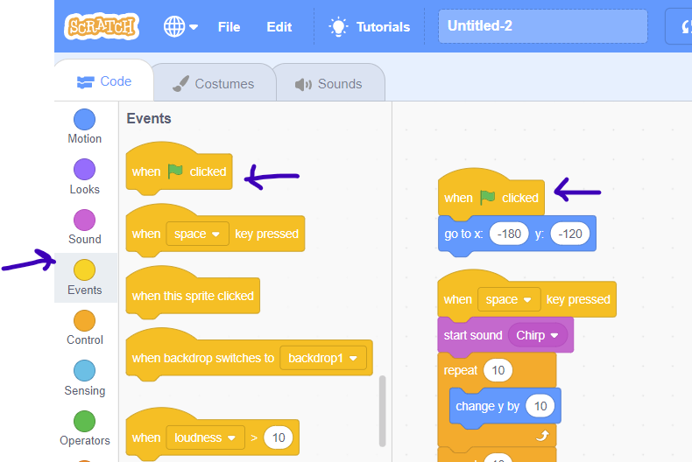

1. Add more obstacles in this case another egg by right clicking on the egg sprite and pressing duplicate. Make sure that the egg2 has the highlighted numbers.

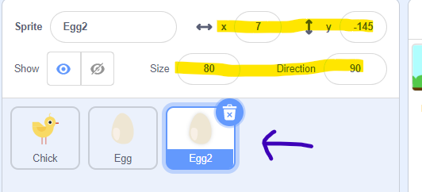

1. Go into the control section and add wait 1 second after the wait green flag clicked and before the forever. Also change the value that follows after glide to 3. Make sure the value in glide is 3 for both of the eggs.

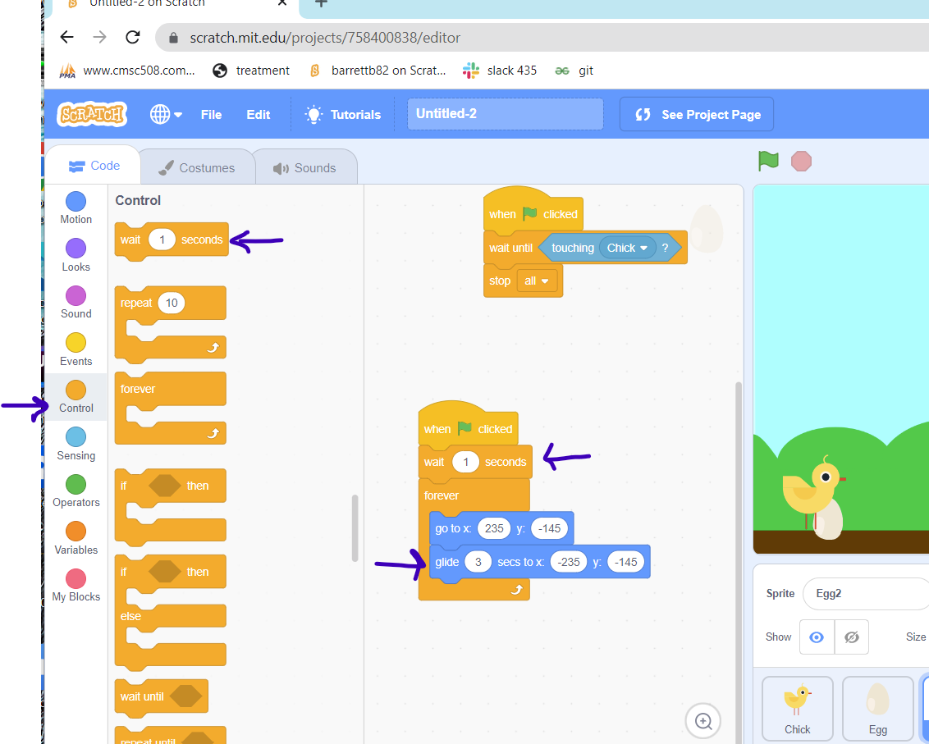

1. Go to the looks section and pull the hide block to have one after the wait green flag click and before the wait 1 second. Then also place one show block connected to the wait 1 second.

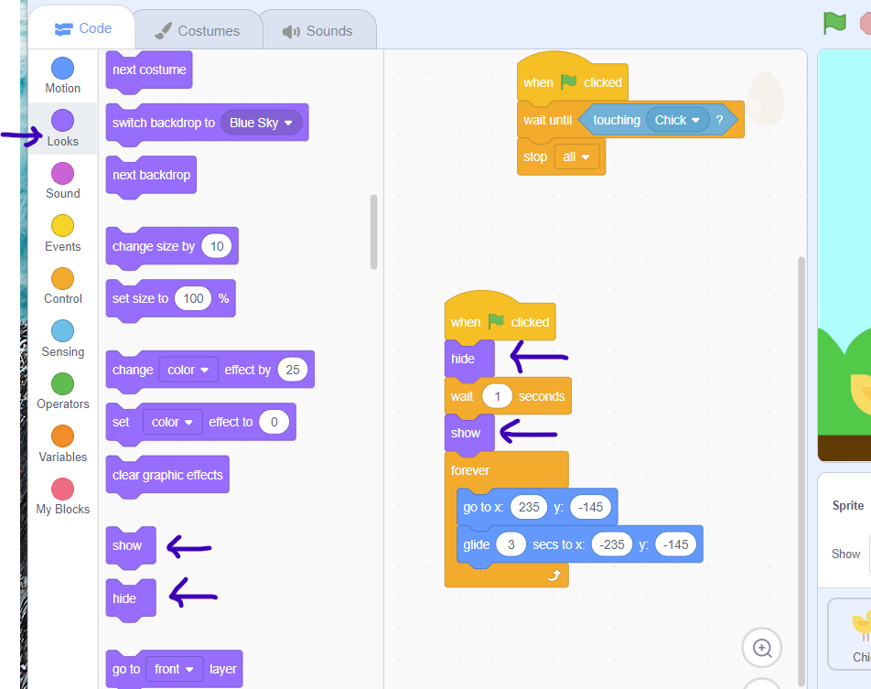

1. Click on the chick sprite. Go into the variable and click on make a variable name the variable score.

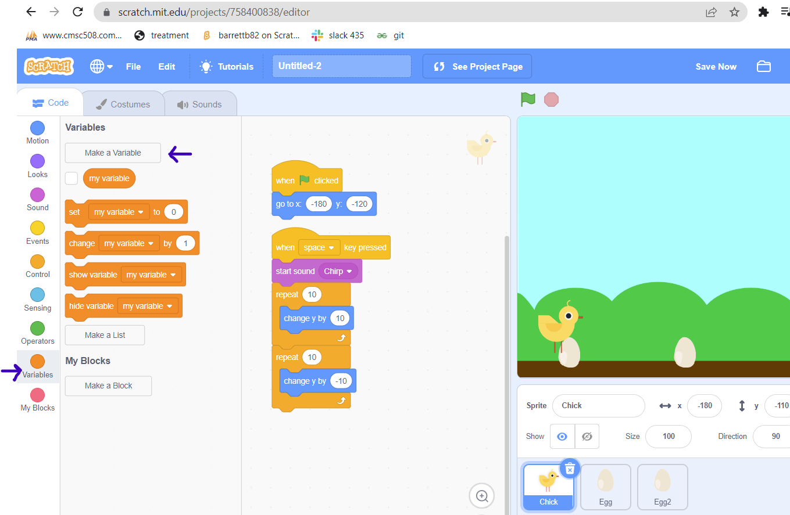

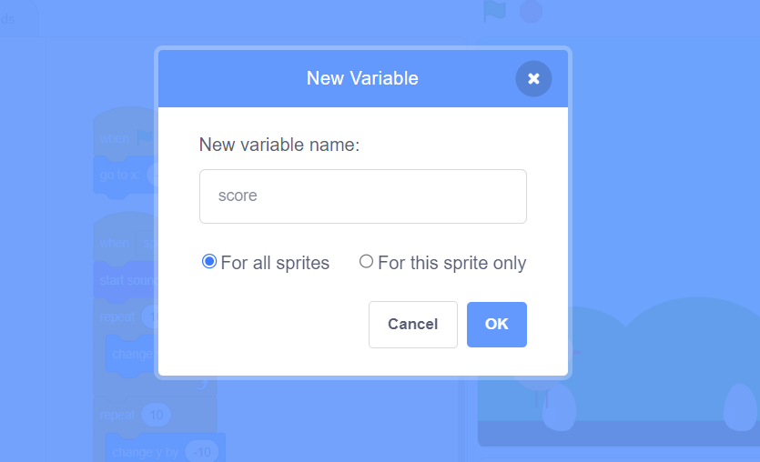

1. Then after the score variable is created connect a “set my variable to 0” after the “go to x block”. Change the my variable drop down to score by clicking on the “my variable” drop down to score then enter the value 2 in the place where 0 is in the original block.

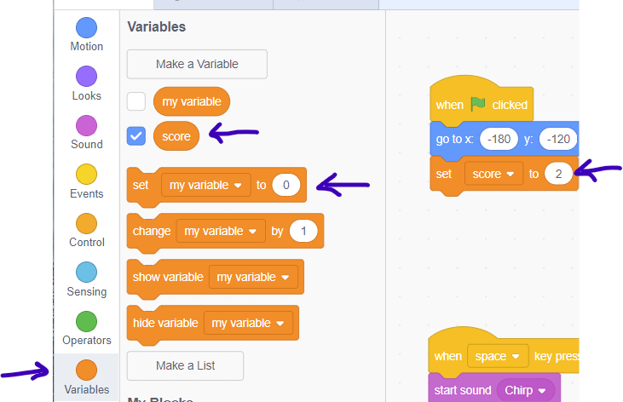

1. Then connect another “change my variable by 1” after the “start sound chirp” block. Change the my variable drop down to score by clicking on the “my variable” drop down and enter the value 1 in the place where 0 is in the original block.

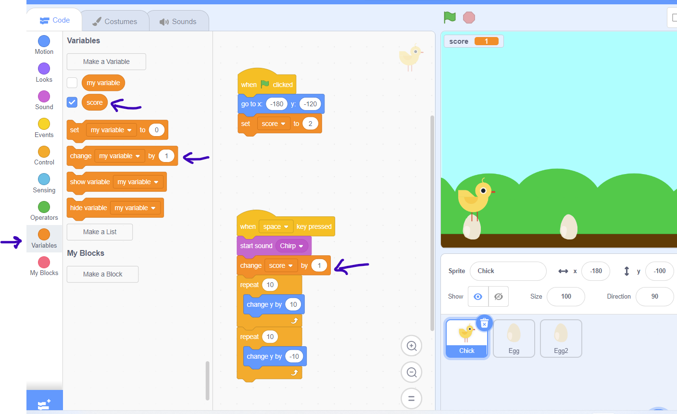

Final snippet of code in Chick Sprite:

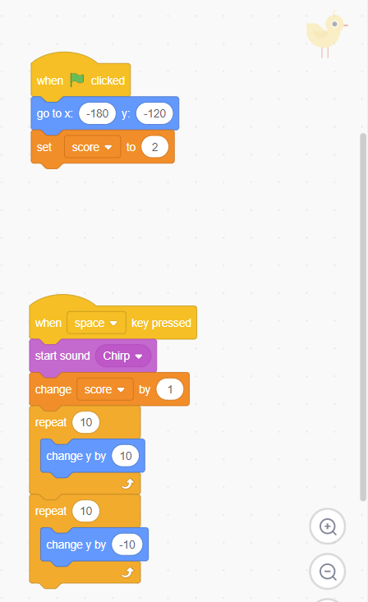

Final snippet of code in Egg:

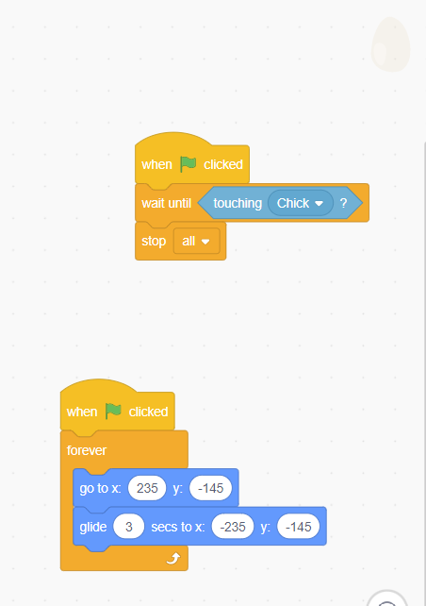

Final snippet of code in Egg2:

